NU-IRB# ………………........ AF 03-10/5.0
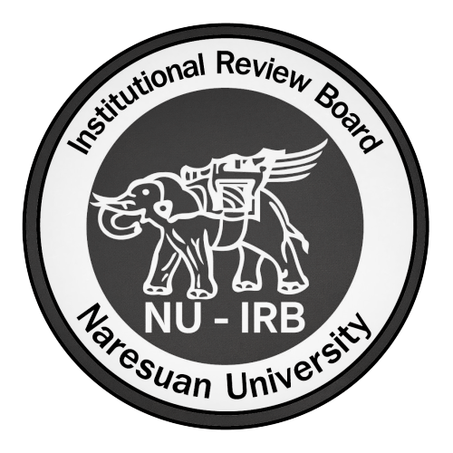 | Institutional Review Board  Naresuan University | Conflict of Interest and Funding Form
Conflict of interest is not in itself a reason for protocol or investigator disapproval. The board will consider its existence and magnitude and whether or not these may affect the scope of protection the right and welfare of human participants. One copy of this form will be forwarded to the conflict of interest committee of the institute. The board will only send the investigator the institute opinion together with protocol approval results.
Protocol Title:
Section 1: Funding
1.1 | Source of funding () |  |  |  |  |  |  |  | amont
 |  |  | None |  |  |  |  |  | ระบุจำนวนค่าใช้จ่าย
 |  |  | Department/ institute
 |  |  | Pharmaceutical company
 |  |  | Other agency:..................................................
 | Grand total |  |  |  |  |  |  |  | ระบุจำนวนค่าใช้จ่าย
1.2 | Investigators fee received () |  |  |  |  |  |  |  | amont
 |  |  | Monthly throughout the project
 |  |  | Lump sum for the whole projectLump sum for the whole project
 |  |  | Per subject recruited
 |  |  | Other agency:.............none.....................................
Section 2: Conflict of Interest () |  |  |  |  |  |  |  |  | Yes | No
2.1 | Do you, members of your family, or associated entity have or receive a financial interest in or from the sponsoring company?
2.2 | Do you hold any executive or scientific position in the sponsoring company?
2.3 | Do you serve as a consultant in scientific, financial, legal issues or a member of a “speaker’s bureau” concerning the products of the sponsoring company?
2.4 | Have you participated in or otherwise influenced any institute transaction with the sponsoring company in any of followings: buying, selling, leasing, licensing, supplying, or making contract?
2.5 | Have you assigned any student, postdoctoral fellow or other trainee, officer, support staff to a project sponsored by the sponsoring company?
2.6 | During 1 year before submission, have you been supported by the sponsoring company to attend conferences/meetings/lecture
 |  | No |  |  | Yes |  |  |  | if yes, please specify
 |  |  |  |  |  | Internal |  | Abroad

Principal Investigator Signature |  | Date | …………………………………..
 | (……………………………………………………………………)
Co-investigator Signature |  | Date | …………………………………..
 | (……………………………………………………………………)
Co-investigator Signature |  | Date | …………………………………..
 | (……………………………………………………………………)

หมายเหตุ: หากทั้งคณะผู้วิจัยไม่มี COI ให้ยื่นแบบฟอร์มร่วมกันได้ แต่หากในคณะผู้วิจัยท่านใดมี COI ให้ยื่นแบบฟอร์มแยก
NOTE: If all investigators do not have COI, a form of COI can be submitted. If there is anyone of investigators has COI, a separated COI form is required for each.

